**Elbow Method for optimal value of k in K-Means**

A fundamental step for any unsupervised algorithm is to determine the optimal number of clusters into which the data may be clustered. The **Elbow Method** is one of the most popular methods to determine this optimal value of k.  
We now demonstrate the given method using the K-Means clustering technique ~~using~~ the **Sklearn** library of python.

Python3

**from** **sklearn.cluster** **import** KMeans

**from** **sklearn** **import** metrics

**from** **scipy.spatial.distance** **import** cdist

**import** **numpy** **as** **np**

**import** **matplotlib.pyplot** **as** **plt**

**Step 2: Creating and Visualizing the data**

Python3

*# Creating the data*

x1 = np.array([3, 1, 1, 2, 1, 6, 6, 6, 5, 6, 7, 8, 9, 8, 9, 9, 8])

x2 = np.array([5, 4, 5, 6, 5, 8, 6, 7, 6, 7, 1, 2, 1, 2, 3, 2, 3])

X = np.array(list(zip(x1, x2))).reshape(len(x1), 2)

*# Visualizing the data*

plt.plot()

plt.xlim([0, 10])

plt.ylim([0, 10])

plt.title('Dataset')

plt.scatter(x1, x2)

plt.show()

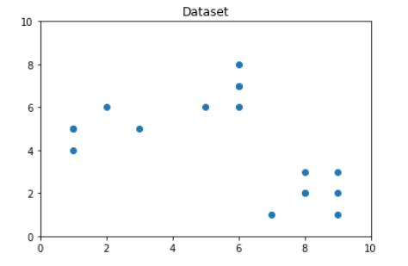

We iterate the values of k from 1 to 9 and calculate the values of distortions for each value of k and calculate the distortion and inertia for each value of k in the given range.  
**Step 3: Building the clustering model and calculating the values of the Distortion and Inertia:**

Python3

distortions = []

inertias = []

mapping1 = {}

mapping2 = {}

K = range(1, 10)

**for** k **in** K:

*# Building and fitting the model*

kmeanModel = KMeans(n_clusters=k).fit(X)

kmeanModel.fit(X)

distortions.append(sum(np.min(cdist(X, kmeanModel.cluster_centers_,

'euclidean'), axis=1)) / X.shape[0])

inertias.append(kmeanModel.inertia_)

mapping1[k] = sum(np.min(cdist(X, kmeanModel.cluster_centers_,

'euclidean'), axis=1)) / X.shape[0]

mapping2[k] = kmeanModel.inertia_

Python3

plt.plot(K, distortions, 'bx-')

plt.xlabel('Values of K')

plt.ylabel('Distortion')

plt.title('The Elbow Method using Distortion')

plt.show()

